**Week-3**

**Spring Core and Maven**

**Exercise 1: Configuring a Basic Spring Application**

**Scenario:**

Your company is developing a web application for managing a library. You need to use the Spring Framework to handle the backend operations.

**Steps:**

1. **Set Up a Spring Project:**
   * Create a Maven project named **LibraryManagement**.
   * Add Spring Core dependencies in the **pom.xml** file.

**pom.xml code:**

<?xml version="1.0" encoding="UTF-8"?>  
<project xmlns="http://maven.apache.org/POM/4.0.0"  
 xmlns:xsi="http://www.w3.org/2001/XMLSchema-instance"  
 xsi:schemaLocation="http://maven.apache.org/POM/4.0.0  
 http://maven.apache.org/xsd/maven-4.0.0.xsd">  
 <modelVersion>4.0.0</modelVersion>  
 <groupId>com.library</groupId>  
 <artifactId>LibraryManagement</artifactId>  
 <version>1.0-SNAPSHOT</version>  
 <properties>  
 <project.build.sourceEncoding>UTF-8</project.build.sourceEncoding>  
 </properties>  
 <dependencies>  
 <!-- JUnit for testing -->  
 <dependency>  
 <groupId>org.junit.jupiter</groupId>  
 <artifactId>junit-jupiter-api</artifactId>  
 <version>5.10.0</version>  
 <scope>test</scope>  
 </dependency>  
 <!--Spring Core -->  
 <dependency>  
 <groupId>org.springframework</groupId>  
 <artifactId>spring-context</artifactId>  
 <version>5.3.32</version>  
 </dependency>  
 </dependencies>  
 <!-- Set Java version using compiler plugin -->  
 <build>  
 <plugins>  
 <plugin>  
 <groupId>org.apache.maven.plugins</groupId>  
 <artifactId>maven-compiler-plugin</artifactId>  
 <version>11</version>  
 <configuration>  
 <source>11</source>  
 <target>11</target>  
 </configuration>  
 </plugin>  
 </plugins>  
 </build>  
</project>

1. **Configure the Application Context:**
   * Create an XML configuration file named **applicationContext.xml** in the **src/main/resources** directory.
   * Define beans for **BookService** and **BookRepository** in the XML file.

**applicationContext.xml code:**

<?xml version="1.0" encoding="UTF-8"?>  
<beans xmlns="http://www.springframework.org/schema/beans"  
 xmlns:xsi="http://www.w3.org/2001/XMLSchema-instance"  
 xsi:schemaLocation="http://www.springframework.org/schema/beans  
 http://www.springframework.org/schema/beans/spring-beans.xsd">  
 <!-- Repository Bean -->  
 <bean id="bookRepository" class="com.library.repository.BookRepository" />  
 <!-- Service Bean and Dependency Injection -->  
 <bean id="bookService" class="com.library.service.BookService">  
 <property name="bookRepository" ref="bookRepository" />  
 </bean>  
</beans>

1. **Define Service and Repository Classes:**
   * Create a package **com.library.service** and add a class **BookService**.
   * Create a package **com.library.repository** and add a class **BookRepository**.

**BookRepository.java code:**

package com.library.repository;  
  
public class BookRepository {  
 public void saveBook(String title) {  
 System.*out*.println("Book saved: " + title); }  
}

**BookService.java code:**

package com.library.service;  
  
import com.library.repository.BookRepository;  
  
public class BookService {  
 private BookRepository bookRepository;  
  
 // Setter method for Spring to inject BookRepository  
 public void setBookRepository(BookRepository bookRepository) {  
 this.bookRepository = bookRepository;  
 }  
  
 public void addBook(String title) {  
 System.*out*.println("Adding book in service...");  
 bookRepository.saveBook(title);  
 }  
}

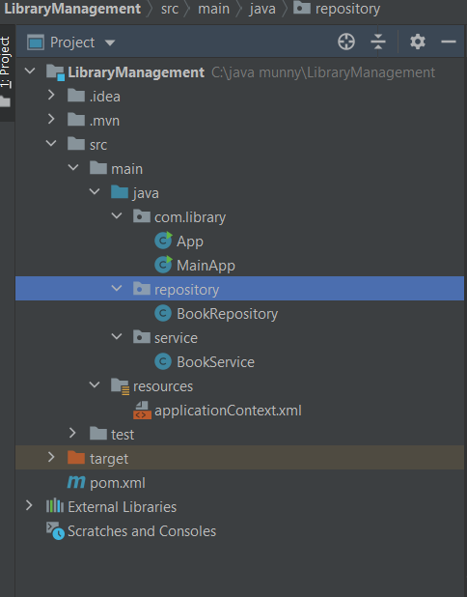

1. **Run the Application:**
   * Create a main class to load the Spring context and test the configuration.

**MainApp.java:**

package com.library;  
  
import com.library.service.BookService;  
import org.springframework.context.ApplicationContext;  
import org.springframework.context.support.ClassPathXmlApplicationContext;  
  
public class MainApp {  
 public static void main(String[] args) {  
 // Load Spring container  
 ApplicationContext context = new ClassPathXmlApplicationContext("applicationContext.xml");  
  
 // Get BookService bean from Spring  
 BookService bookService = context.getBean("bookService", BookService.class);  
  
 // Call service method  
 bookService.addBook("Spring in Action");  
 }  
}

**Output:**

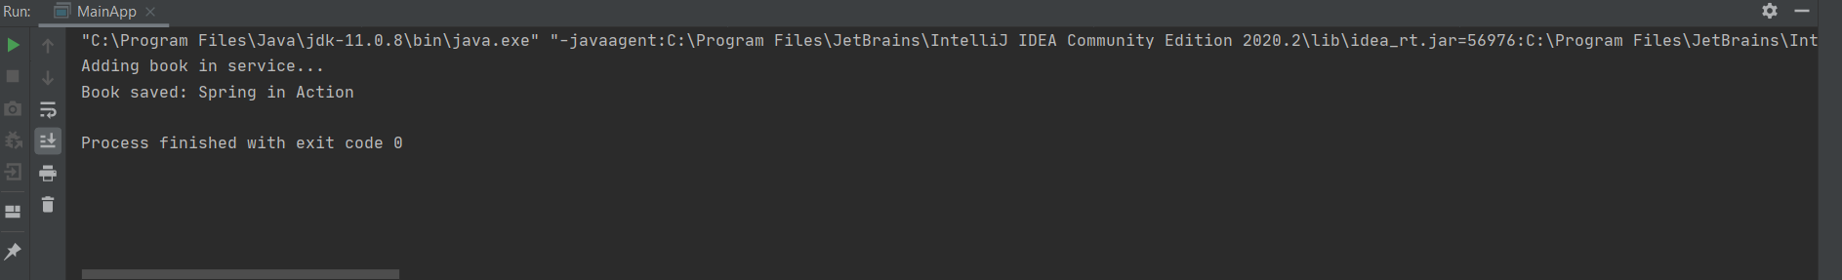

**Exercise 2: Implementing Dependency Injection**

**Scenario:**

In the library management application, you need to manage the dependencies between the BookService and BookRepository classes using Spring's IoC and DI.

**Steps:**

1. **Modify the XML Configuration:**
   * Update applicationContext.xml to wire BookRepository into BookService.

**applicationContext.xml code:**

<beans xmlns="http://www.springframework.org/schema/beans"  
 xmlns:xsi="http://www.w3.org/2001/XMLSchema-instance"  
 xsi:schemaLocation="http://www.springframework.org/schema/beans  
 http://www.springframework.org/schema/beans/spring-beans.xsd">  
  
 <bean id="bookRepository" class="com.library.repository.BookRepository" />  
  
 <bean id="bookService" class="com.library.service.BookService">  
 <property name="bookRepository" ref="bookRepository" />  
 </bean>  
</beans>

1. **Update the BookService Class:**
   * Ensure that BookService class has a setter method for BookRepository.

**BookService.java code:**

package com.library.service;  
  
import com.library.repository.BookRepository;  
  
public class BookService {  
  
 private BookRepository bookRepository;  
  
 public BookService() {  
 System.*out*.println("BookService: Bean created by Spring");  
 }  
  
 // Setter injection method  
 public void setBookRepository(BookRepository bookRepository) {  
 System.*out*.println("BookService: BookRepository injected via setter");  
 this.bookRepository = bookRepository;  
 }  
  
 public void addBook(String title) {  
 System.*out*.println("BookService: Adding book in service...");  
 bookRepository.saveBook(title);  
 }  
}

1. **Test the Configuration:**

Run the LibraryManagementApplication main class to verify the dependency injection

**MainApp.java code:**

package com.library;  
  
import com.library.service.BookService;  
import org.springframework.context.ApplicationContext;  
import org.springframework.context.support.ClassPathXmlApplicationContext;  
  
public class MainApp {  
 public static void main(String[] args) {  
 System.*out*.println("Loading Spring ApplicationContext...");  
 ApplicationContext context = new ClassPathXmlApplicationContext("applicationContext.xml");  
  
 BookService bookService = context.getBean("bookService", BookService.class);  
 bookService.addBook("Spring in Action");  
 }  
}

**Output:**

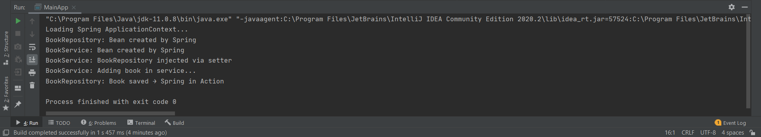

**Exercise 4: Creating and Configuring a Maven Project**

**Scenario:**

You need to set up a new Maven project for the library management application and add Spring dependencies.

**Steps:**

1. **Create a New Maven Project:**
   * Create a new Maven project named LibraryManagement.
2. **Add Spring Dependencies in pom.xml:**
   * Include dependencies for Spring Context, Spring AOP, and Spring WebMVC.

**pom.xml code:**

<?xml version="1.0" encoding="UTF-8"?>  
<project xmlns="http://maven.apache.org/POM/4.0.0"  
 xmlns:xsi="http://www.w3.org/2001/XMLSchema-instance"  
 xsi:schemaLocation="http://maven.apache.org/POM/4.0.0  
 http://maven.apache.org/xsd/maven-4.0.0.xsd">  
 <modelVersion>4.0.0</modelVersion>  
  
 <groupId>com.library</groupId>  
 <artifactId>LibraryManagement</artifactId>  
 <version>1.0-SNAPSHOT</version>  
  
 <properties>  
 <maven.compiler.source>1.8</maven.compiler.source>  
 <maven.compiler.target>1.8</maven.compiler.target>  
 <project.build.sourceEncoding>UTF-8</project.build.sourceEncoding>  
 </properties>  
  
 <dependencies>  
 <!-- Spring Context -->  
 <dependency>  
 <groupId>org.springframework</groupId>  
 <artifactId>spring-context</artifactId>  
 <version>5.3.32</version>  
 </dependency>  
  
 <!-- Spring AOP -->  
 <dependency>  
 <groupId>org.springframework</groupId>  
 <artifactId>spring-aop</artifactId>  
 <version>5.3.32</version>  
 </dependency>  
  
 <!-- Spring WebMVC -->  
 <dependency>  
 <groupId>org.springframework</groupId>  
 <artifactId>spring-webmvc</artifactId>  
 <version>5.3.32</version>  
 </dependency>  
  
 <!-- JUnit Jupiter API (for writing tests) -->  
 <dependency>  
 <groupId>org.junit.jupiter</groupId>  
 <artifactId>junit-jupiter-api</artifactId>  
 <version>5.10.0</version>  
 <scope>test</scope>  
 </dependency>  
  
 <!-- JUnit Jupiter Engine (for running tests) -->  
 <dependency>  
 <groupId>org.junit.jupiter</groupId>  
 <artifactId>junit-jupiter-engine</artifactId>  
 <version>5.10.0</version>  
 <scope>test</scope>  
 </dependency>  
 </dependencies>  
  
 <!-- Maven Compiler Plugin for Java 8 -->  
 <build>  
 <plugins>  
 <plugin>  
 <groupId>org.apache.maven.plugins</groupId>  
 <artifactId>maven-compiler-plugin</artifactId>  
 <version>3.10.1</version>  
 <configuration>  
 <source>1.8</source>  
 <target>1.8</target>  
 </configuration>  
 </plugin>  
 </plugins>  
 </build>  
</project>

1. **Configure Maven Plugins:**
   * Configure the Maven Compiler Plugin for Java version 1.8 in the pom.xml file.

**MainApp.java code:**

package com.library;  
  
public class MainApp {  
 public static void main(String[] args) {  
 System.*out*.println("Spring + Maven project setup successful with Java 1.8!");  
 }  
}

**Output:**

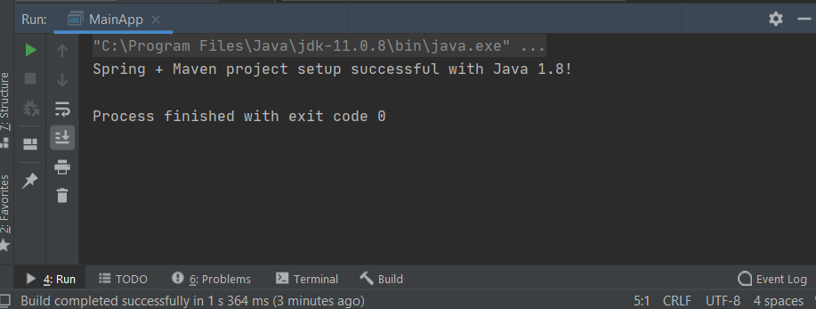

**SPRING DATA JPA WITH SPRINGBOOT, HIBERNATE :**

**Hands-on 4: Spring Data JPA – Quick Example**

Create a MySQL database named ormlearn and a table Country with columns code and name.

* Insert sample data (e.g., 'IN', 'India') into the table.
* Use Spring Initializr to generate a project with dependencies: Spring Boot DevTools, Spring Data JPA, and MySQL Driver.
* Create Country entity class, CountryRepository, and CountryService.
* In the main class, fetch all countries from the database using countryService.getAllCountries() and display the result.
* Include proper configuration in application.properties.

**CODE :**

**Country.java**

package com.cognizant.ormlearn.model;  
  
import jakarta.persistence.Column;  
import jakarta.persistence.Entity;  
import jakarta.persistence.Id;  
import jakarta.persistence.Table;  
  
@Entity  
@Table(name = "country")  
public class Country {  
  
 @Id  
 @Column(name = "code")  
 private String code;  
  
 @Column(name = "name")  
 private String name;  
  
 public String getCode() {  
 return code;  
 }  
  
 public void setCode(String code) {  
 this.code = code;  
 }  
  
 public String getName() {  
 return name;  
 }  
  
 public void setName(String name) {  
 this.name = name;  
 }  
  
 @Override  
 public String toString() {  
 return "Country [code=" + code + ", name=" + name + "]";  
 }  
}

**CountryService.java**

package com.cognizant.ormlearn.service;  
  
import com.cognizant.ormlearn.model.Country;  
import com.cognizant.ormlearn.repository.CountryRepository;  
import org.springframework.beans.factory.annotation.Autowired;  
import org.springframework.stereotype.Service;  
import org.springframework.transaction.annotation.Transactional;  
  
import java.util.List;  
  
@Service  
public class CountryService {  
  
 @Autowired  
 private CountryRepository countryRepository;  
  
 @Transactional  
 public List<Country> getAllCountries() {  
 return countryRepository.findAll();  
 }  
}

**CountryRepository.java**

package com.cognizant.ormlearn.repository;  
  
import org.springframework.data.jpa.repository.JpaRepository;  
import org.springframework.stereotype.Repository;  
  
import com.cognizant.ormlearn.model.Country;  
  
@Repository  
public interface CountryRepository extends JpaRepository<Country, String> {  
}

**OrmLearnApplication.java**

import com.cognizant.ormlearn.model.Country;  
import com.cognizant.ormlearn.service.CountryService;  
import org.slf4j.Logger;  
import org.slf4j.LoggerFactory;  
import org.springframework.boot.SpringApplication;  
import org.springframework.boot.autoconfigure.SpringBootApplication;  
import org.springframework.context.ApplicationContext;  
  
import java.util.List;  
  
@SpringBootApplication  
public class OrmLearnApplication {  
  
 private static final Logger *LOGGER* = LoggerFactory.getLogger(OrmLearnApplication.class);  
  
 private static CountryService *countryService*;  
  
 public static void main(String[] args) {  
 *LOGGER*.info("Inside main");  
  
 ApplicationContext context = SpringApplication.run(OrmLearnApplication.class, args);  
 *countryService* = context.getBean(CountryService.class);  
  
 *testGetAllCountries*();  
 }  
  
 private static void testGetAllCountries() {  
 *LOGGER*.info("Start");  
 List<Country> countries = *countryService*.getAllCountries();  
 *LOGGER*.debug("countries={}", countries);  
 *LOGGER*.info("End");  
 }  
}

**application.properties**

# Spring Framework and application log  
logging.level.org.springframework=info  
logging.level.com.cognizant=debug  
  
# Hibernate logs for displaying executed SQL, input and output  
logging.level.org.hibernate.SQL=trace  
logging.level.org.hibernate.type.descriptor.sql=trace  
  
# Log pattern  
logging.pattern.console=%d{dd-MM-yy} %d{HH:mm:ss.SSS} %-20.20thread %5p %-25.25logger{25} %25M %4L %m%n  
  
# Database configuration  
spring.datasource.driver-class-name=com.mysql.cj.jdbc.Driver  
spring.datasource.url=jdbc:mysql://localhost:3306/ormlearn  
spring.datasource.username=root  
spring.datasource.password=root  
  
# Hibernate configuration  
spring.jpa.hibernate.ddl-auto=validate  
spring.jpa.properties.hibernate.dialect=org.hibernate.dialect.MySQL5Dialect

**pom.xml**

<?xml version="1.0" encoding="UTF-8"?>  
<project xmlns="http://maven.apache.org/POM/4.0.0"  
 xmlns:xsi="http://www.w3.org/2001/XMLSchema-instance"  
 xsi:schemaLocation="http://maven.apache.org/POM/4.0.0 https://maven.apache.org/xsd/maven-4.0.0.xsd">  
 <modelVersion>4.0.0</modelVersion>  
  
 <parent>  
 <groupId>org.springframework.boot</groupId>  
 <artifactId>spring-boot-starter-parent</artifactId>  
 <version>3.2.4</version> <!-- This is STABLE and latest -->  
 <relativePath/>  
 </parent>  
  
 <groupId>com.cognizant</groupId>  
 <artifactId>orm-learn</artifactId>  
 <version>0.0.1-SNAPSHOT</version>  
 <name>orm-learn</name>  
 <description>Demo project for Spring Data JPA and Hibernate</description>  
  
 <properties>  
 <java.version>17</java.version>  
 </properties>  
  
 <dependencies>  
 <!-- Spring Boot JPA -->  
 <dependency>  
 <groupId>org.springframework.boot</groupId>  
 <artifactId>spring-boot-starter-data-jpa</artifactId>  
 </dependency>  
  
 <!-- MySQL Connector -->  
 <dependency>  
 <groupId>com.mysql</groupId>  
 <artifactId>mysql-connector-j</artifactId>  
 <scope>runtime</scope>  
 </dependency>  
  
 <!-- Jakarta Persistence -->  
 <dependency>  
 <groupId>jakarta.persistence</groupId>  
 <artifactId>jakarta.persistence-api</artifactId>  
 <version>3.1.0</version>  
 </dependency>  
  
 <!-- DevTools -->  
 <dependency>  
 <groupId>org.springframework.boot</groupId>  
 <artifactId>spring-boot-devtools</artifactId>  
 <scope>runtime</scope>  
 <optional>true</optional>  
 </dependency>  
  
 <!-- Testing -->  
 <dependency>  
 <groupId>org.springframework.boot</groupId>  
 <artifactId>spring-boot-starter-test</artifactId>  
 <scope>test</scope>  
 </dependency>  
 </dependencies>  
  
 <build>  
 <plugins>  
 <plugin>  
 <groupId>org.springframework.boot</groupId>  
 <artifactId>spring-boot-maven-plugin</artifactId>  
 </plugin>  
 </plugins>  
 </build>  
</project>

**Output:**

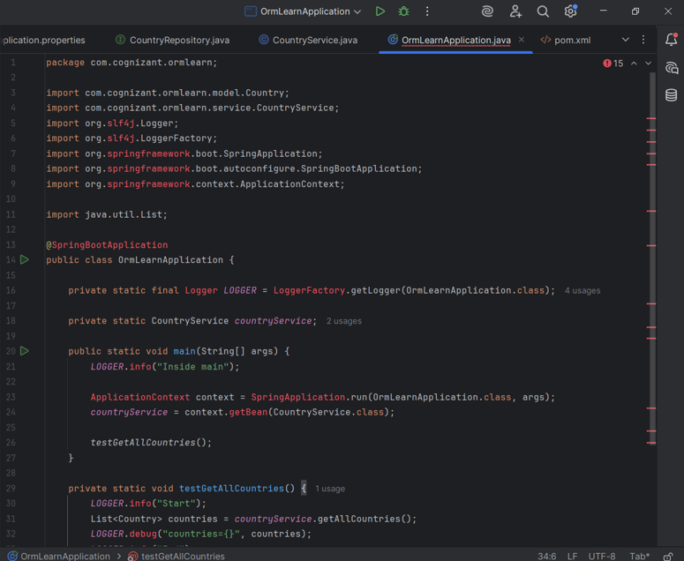

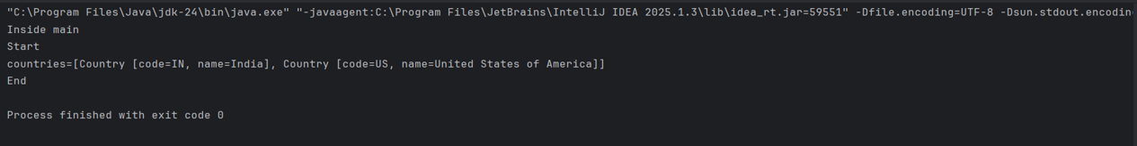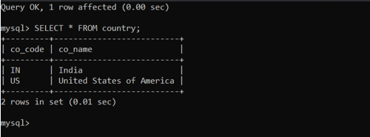

**Hands-on 4: Difference between JPA, Hibernate, and Spring Data JPA**

Compare JPA, Hibernate, and Spring Data JPA. Provide code snippets to illustrate how the implementation differs between Hibernate and Spring Data JPA

**Differences :**

|  |  |  |
| --- | --- | --- |
| **JPA (Java Persistence API)** | **Hibernate** | **Spring Data JPA** |
| A specification that defines how to persist data in Java. | A popular ORM (Object Relational Mapping) tool and JPA implementation. | A Spring-based abstraction that builds on top of JPA, simplifying DB operations. |
| Specification only (needs implementation like Hibernate). | Concrete implementation of JPA. | Framework built on top of JPA and uses implementations like Hibernate underneath. |
| Manually managed (via EntityManager). | Manually handled using Session and Transaction. | Spring handles this automatically using annotations like @Transaction. |
| Requires writing more boilerplate code. | Slightly less, but still requires session handling. | Very minimal code; uses Spring-provided repositories. |
| When you want full control over database interactions. | When you prefer a mature ORM solution with powerful features. | When rapid development and less code is your priority (especially with Spring Boot). |
| Intermediate | Intermediate to Advanced | Beginner-friendly, especially if you're familiar with Spring. |

**Code Comparison: Hibernate vs Spring Data JPA (Adding an Employee) :**

*This section demonstrates how* Hibernate *and* Spring Data JPA *differ in terms of boilerplate, simplicity, and abstraction — using a common example: Adding an employee to the database.*

***Hibernate Code:***

public Integer addEmployee(Employee employee){

Session session = factory.openSession();

Transaction tx = null;

Integer employeeID = null;

try {

tx = session.beginTransaction();

employeeID = (Integer) session.save(employee);

tx.commit();

} catch (HibernateException e) {

if (tx != null) tx.rollback();

e.printStackTrace();

} finally {

session.close();

}

return employeeID;

}

**Explanation:**

* 1. Need to handle sessions, transactions, and exceptions by yourself manually.2. More boilerplate code required.
  2. Have to write more repetitive and extra code to make things work.

**Spring Data JPA Code:**

**EmployeeRepository.java**

public interface EmployeeRepository extends JpaRepository<Employee, Integer> {

}

**EmployeeService.java**

@Autowired

private EmployeeRepository employeeRepository;

@Transactional

public void addEmployee(Employee employee) {

employeeRepository.save(employee);

}

**Explanation:**

1. You don’t have to manually manage sessions or transactions.
2. You can simply use built-in repository methods because Spring Data JPA handles the complex parts for you.

| **Feature** | **Hibernate** | **Spring Data JPA** |
| --- | --- | --- |
| **Boilerplate Code** | High – you need to write extra code for sessions and transactions | Low – most things are handled automatically by Spring |
| **Simplicity** | More complex – setup and coding takes more effort | Simple – clean and ready-to-use interface |
| **Abstraction Level** | Lower – you control most of the persistence details | Higher – Spring hides most of the low-level persistence work |
| **Ease of Use** | Moderate – needs more learning and effort | Very easy – great for beginners and fast development |